Networking: Source, destination, how packets transferred from source to destination and what is the route it is taking.
General Networking
When your computer is not connected to any network by default it contains a loopback IP address (127.0.0.1)
local (loopback) address: 127.0.0.1
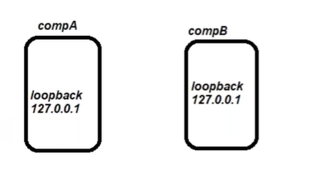
ifconfig
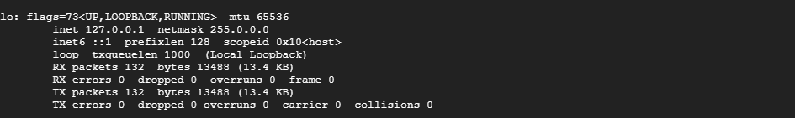

How to establish a communication between two computers?
Using switch (considered as a LAN network). Switch is the device which connects two computers.
When we connect the computer from switch (LAN) it creates an interface eth0 on every node, an IP address is generated in your computer allocated by the switch.
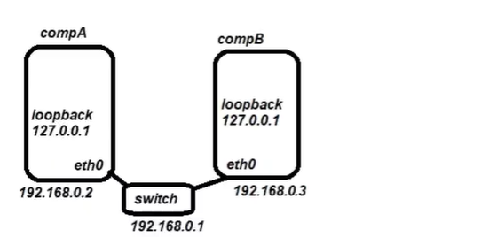

eth0: Interface at vm (IP address allocated by switch)
ens4: vm joins external network (GC).
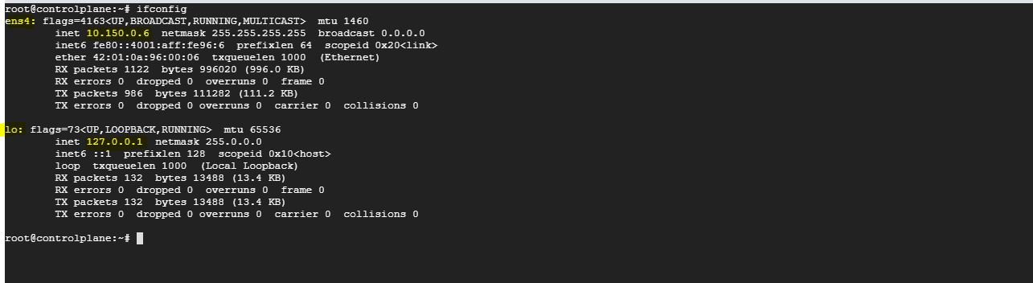
UC: We have another network available.

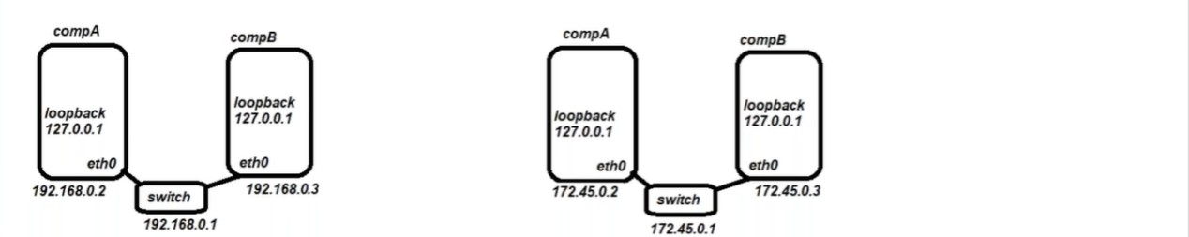

UC: How establish a communication between two different networks, we need to use different device called Router, using Router we can connect different networks Router connects multiple networks. This gets IP address against each network.
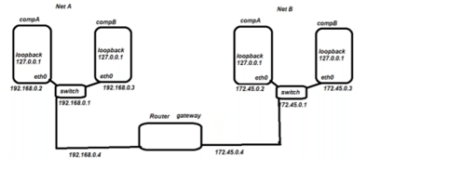
Router is acting as a gateway, from where it allows to connect to the different network.
UC: We have Network C, Network D but we don’t know the IP addresses of that Networks, can we establish a communication with unknown networks also?
Yes, by entering default value 0.0.0.0 in Route table, which indicates to connect to unknown Network.
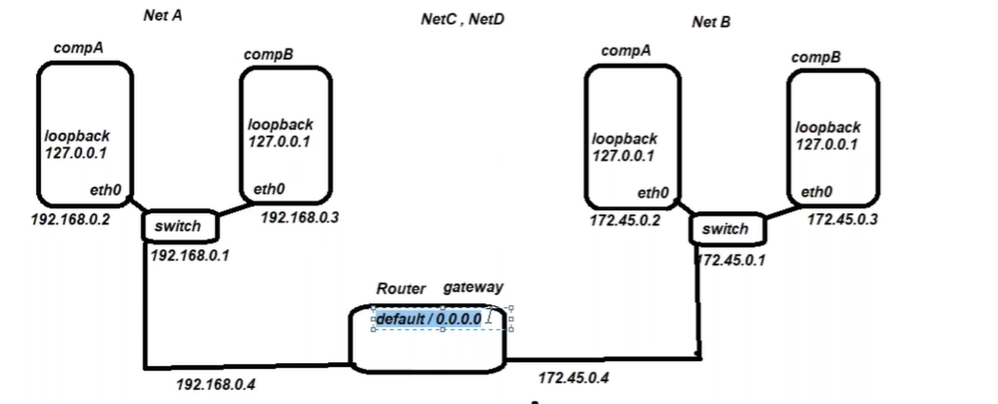

Docker Networking:
What are the network solutions provided by the docker?
docker network ls
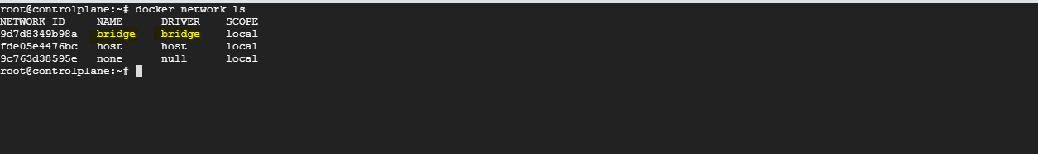
docker0 (CNM): container network model

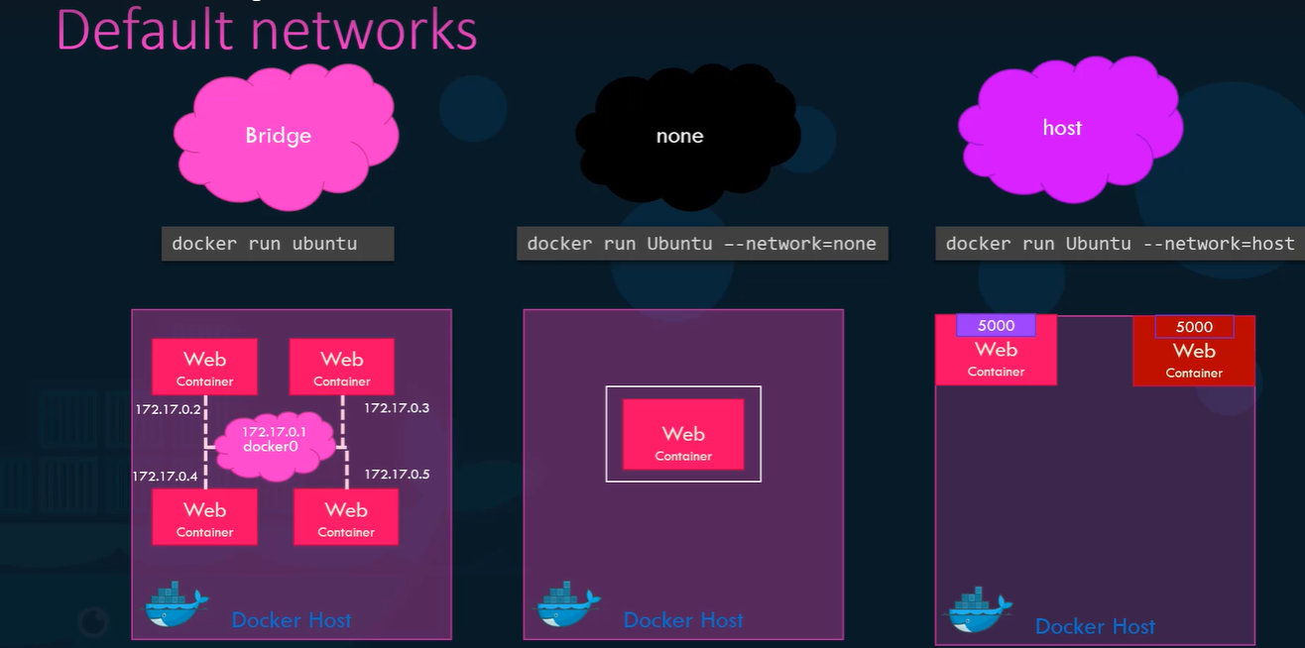
docker inspect <network id>

UC: We have two containers tomcat and nginx, can they communicate to each other by default?
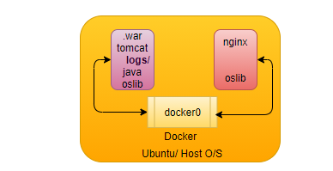

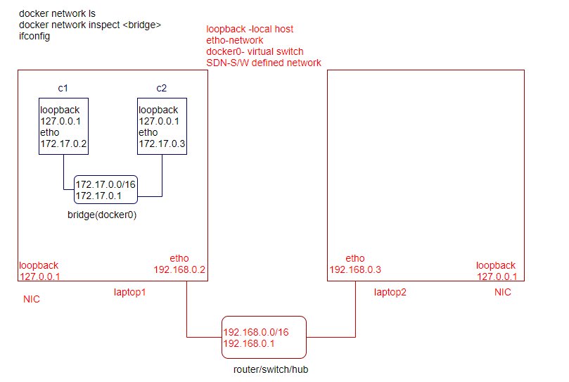
How to containers are able to communicate to each other?
docker by default create a virtual bridge or virtual switch (docker0) for containers communication.
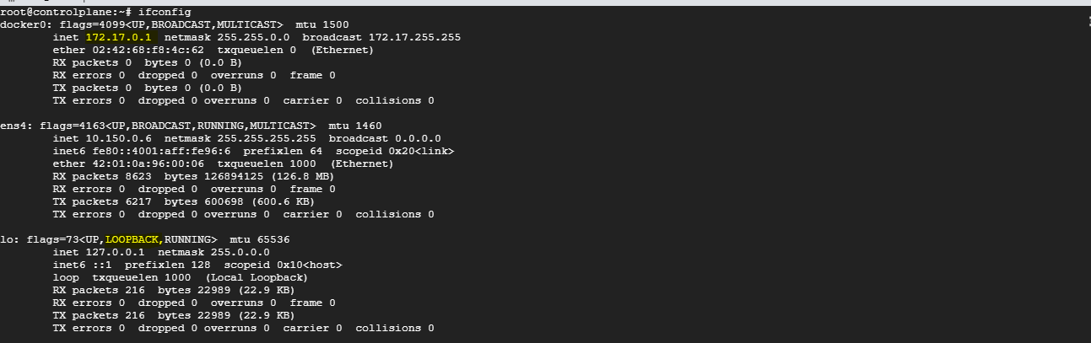
ens4: external network from where your vm gets IP addresses e.g. GCP.
io: Without connecting to any network every host has by default their own LOOPBACK address.
docker0: When we install the docker (virtual switch/interface), created by the docker to container communication within the same host, every container connected through the virtual interface veth0.
Whenever we create a container by default it joins the bridge (docker0) network.
So that every container created in the same host is able to communicate to each other, each container created in the host connected to the virtual switch (docker0) through virtual interface (veth0) is created on each container and an IP address is assigned to veth0.
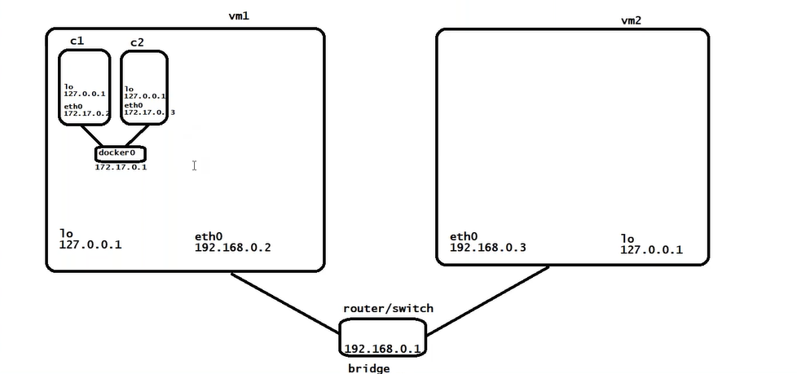

docker container run –d --name=cont1 lerndevops/alpine:sleep
docker container run –d --name=cont2 lerndevops/alpine:sleep
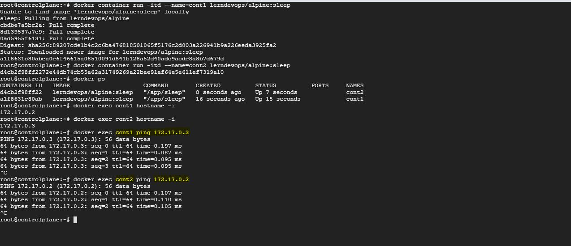
Virtual Switch (bridge network): docker0
Virtual Switch is just like another interface for the host computer to interact with the container.
Virtual Interface (Veth0): Whenever connect to the bridge switch there is a virtual interface is created on each container (veth0) and ip address assigned to veth0.
UC2: customization
How to create your own customized bridge?
docker network create --help
docker network create --driver bridge mybridge1
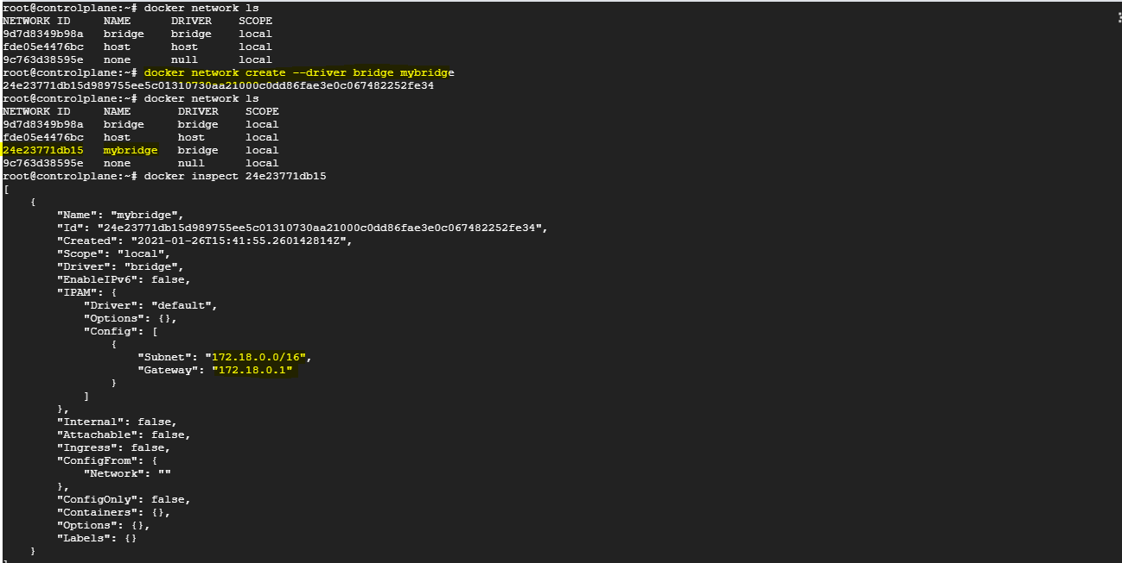
docker network create mybridge --driver bridge --subnet 192.168.0.0/16 --gateway 192.168.0.1

How to create container in customized network?
docker run -d –name=cont3 lerndevops/alpine:sleep # join default bridge
docker run -d –name=cont3 --network mybridge lerndevops/alpine:sleep
docker run -d –name=cont4 --network mybridge lerndevops/alpine:sleep
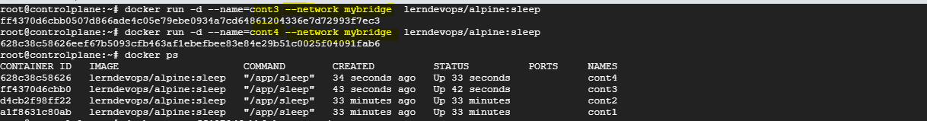
container in default network can communicate to each other but can’t communicate to the containers in custom bridge network, because they are in different subnets.
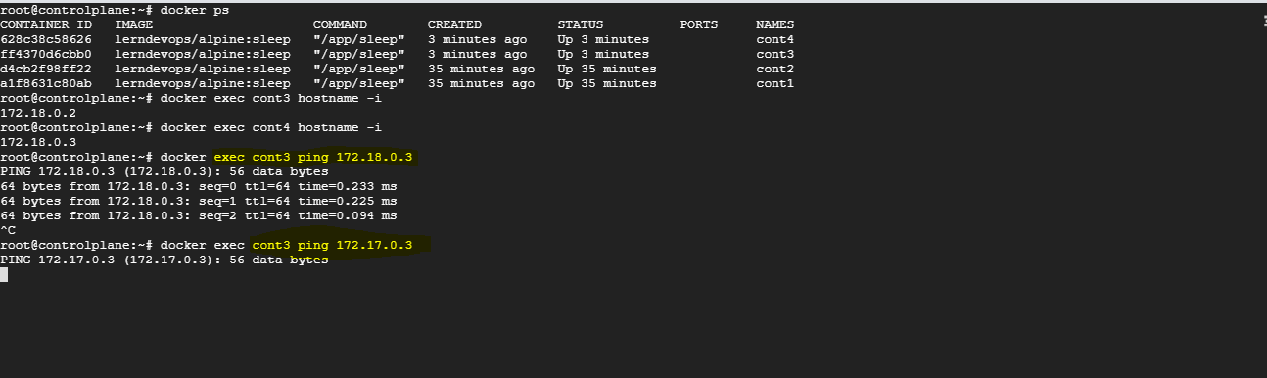
How containers in different networks communicate to each other?
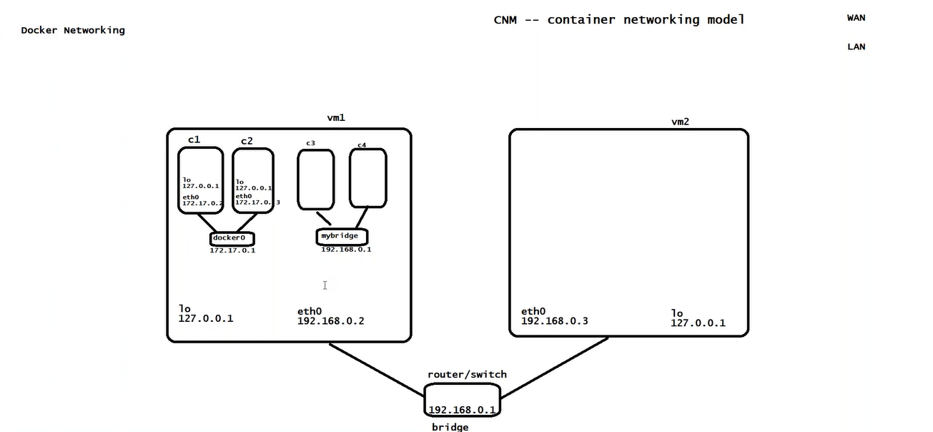

UC: How can cont1 can communicate with cont4?
Solution: join the container in other network also, container can join different networks at same time.
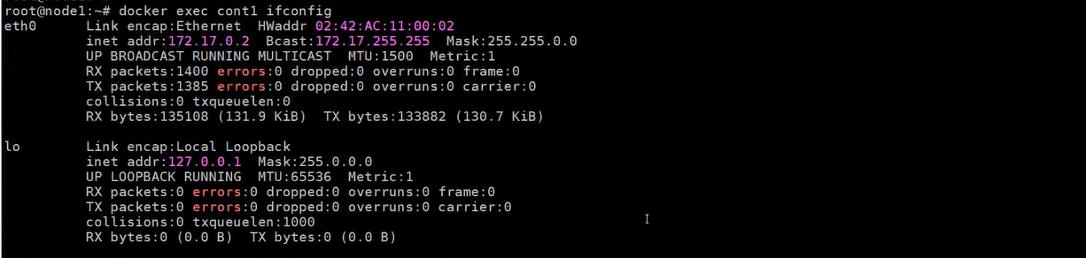
docker network connect cont1 mybridge
Now cont1 have two IP addresses (eth0, eth1), because it’s connected to two different networks.
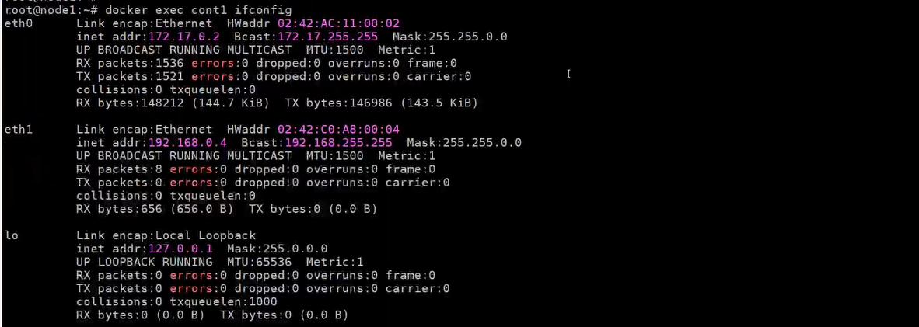

docker network disconnect cont1 mybridge
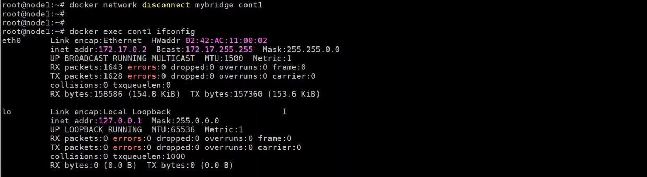
How to create our own subnet ?
docker network create --help
docker network create --driver bridge mybridge1 --subnet=192.168.0.0/16
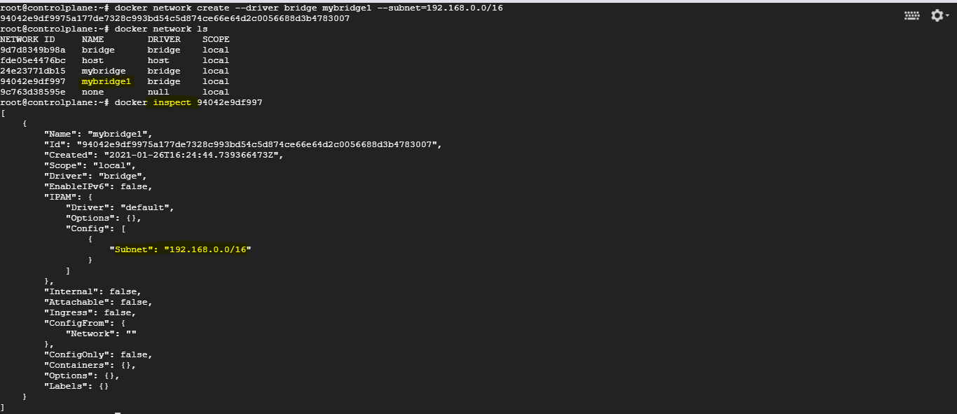
create a container in mybridge1 network
docker run -d --name=cont5 --network mybridge1 lerndevops/alpine:sleep
docker run -d --name=cont6 --network mybridge1 lerndevops/alpine:sleep
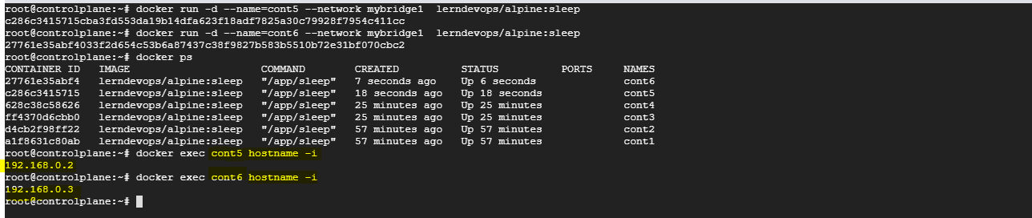
What is none network?
What happen if we switch off our wifi? None network
create a container in none network
docker run -d --name=cont7 --network none lerndevops/alpine:sleep
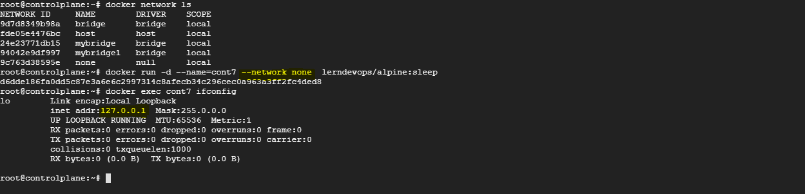
Cont7 is not a part of any network. No eth0 interface, not reachable to outside the world.
It’s a independent process, apart from the default docker networking can use any network provider (CNI), not bounded with docker default (CNM).

What is the purpose of none network?
I am not joining any default docker networking. I can join any networking solution. Used by K8s to join CNI (weave).
This container is all alone container, none container can reach to this, within the local host can access, but from outside none container can access.
UC: Once pullout from local Wifi, can be connected to any network.
I don’t want to use docker’s default network driver, instead we want to install customized network drivers.

What is host network?
create a container in host network
docker run -d --name=cont8 --network host lerndevops/alpine:sleep
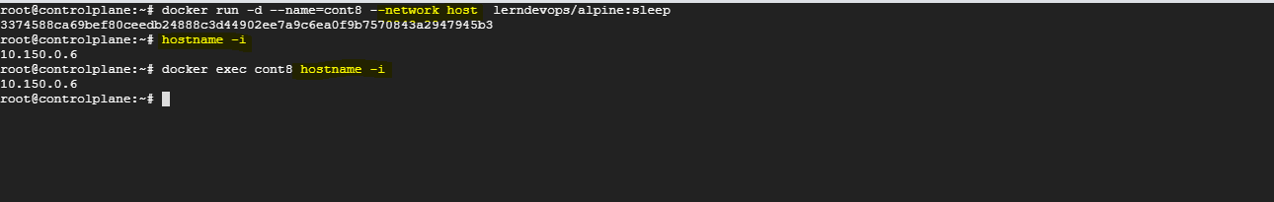
Hey! Container join the host network, there is no docker0 between container and host (port mapping not required).
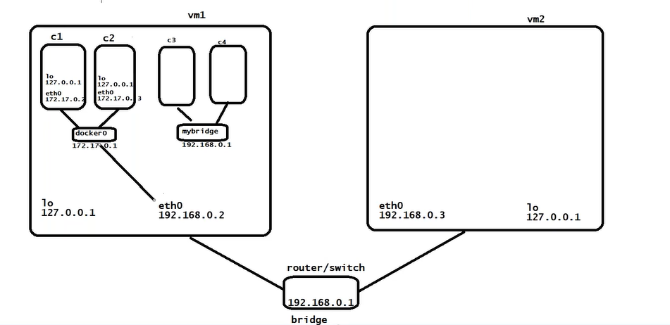
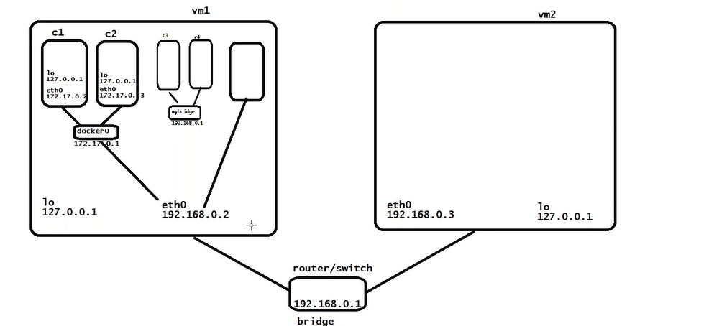
This is not an isolated process now, it’s a process of running on your server. Lose all the isolated feature of the container.
don’t need to publish the port
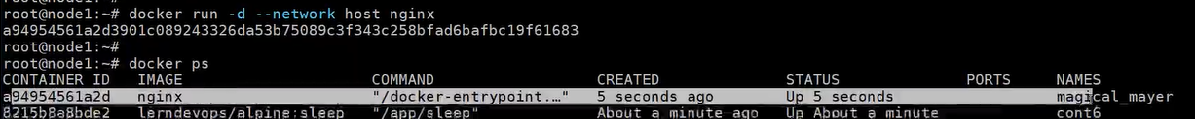
If we try to access the same from browser, it will be accessible, if we try to run same second time?
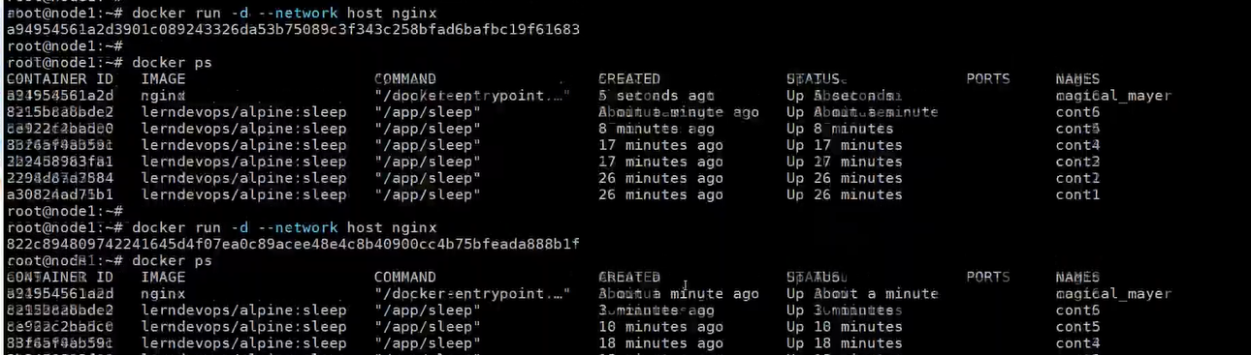
port is already in used.

Limitation: As of now we have discussed the networking within the same host, which is not a realistic scenario.

How containers communicate across different node?
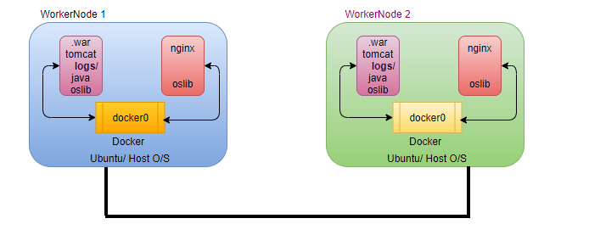
By default, nodes are able to communicate to each other through the underlay network (AWS, GCP)
Can container available in different nodes communicate to each other by default? No
Solution: We have to establish a cluster

In realistic environment we required cluster of at least 3 nodes.
To communicate across multiple docker hosts, we have to first initialize the cluster, go to any container orchestration solution e.g., docker swarm, k8s which manages the containers across the cluster.
Docker swarm:
- Container orchestration tool
- Container management tool
docker swarm comes with the docker installation, and by default it is in inactive state.

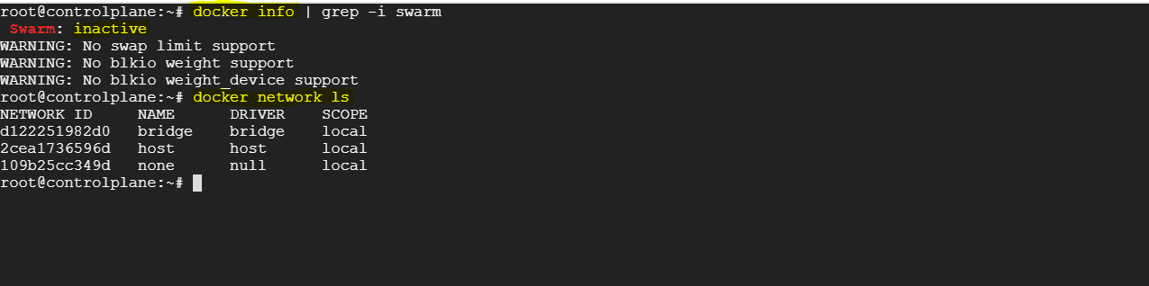

How to activate the swarm?
docker swarm init
As we initialize a docker swarm, docker creates a new extra network which span across the cluster, when you join the multiple docker hosts on the single cluster, docker joins the multiple docker host in single virtual network again as an overlay network.
docker swarm init # In master creates Overlay network
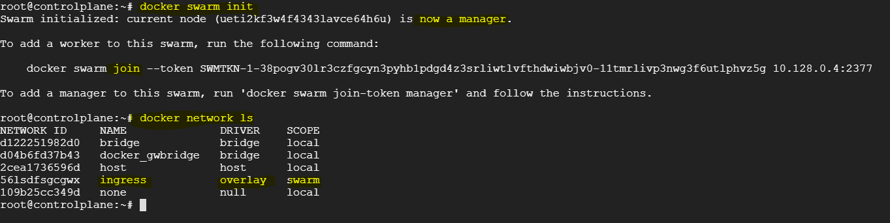
docker inspect <networkId>
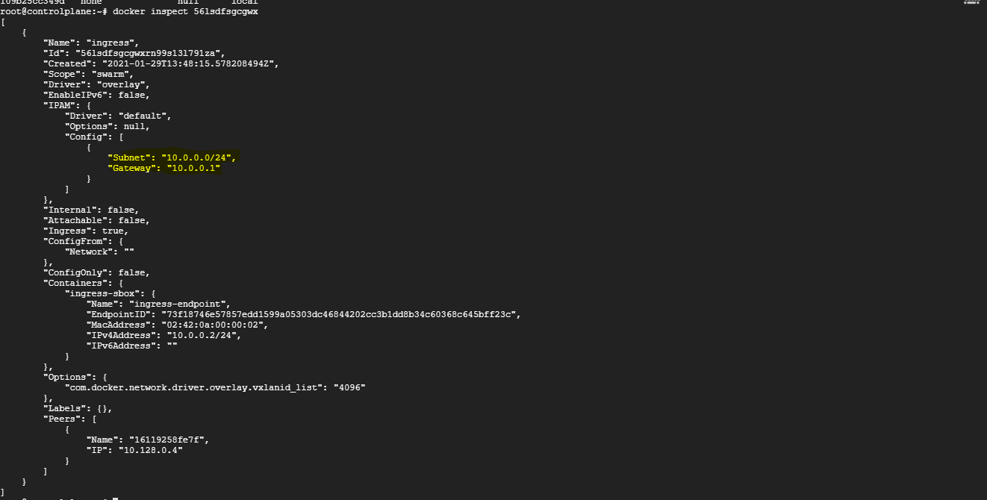

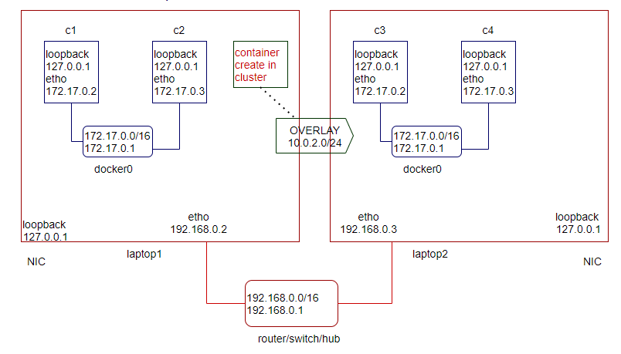
In Worker Node01
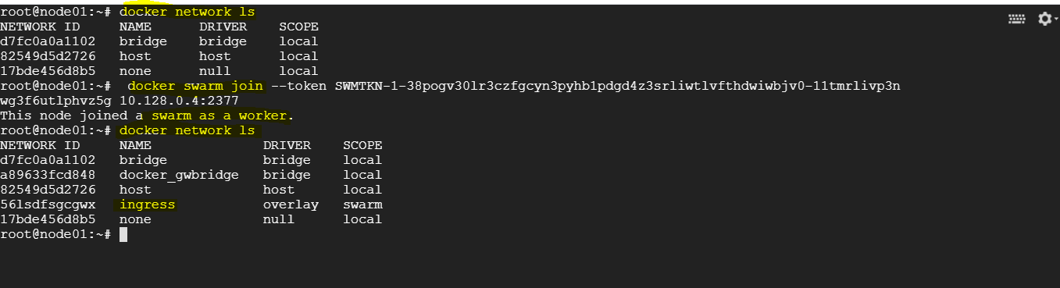
In Worker Node02
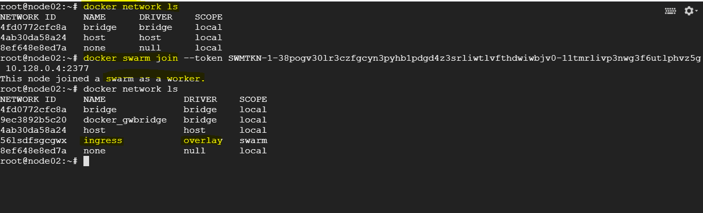
In Master Node
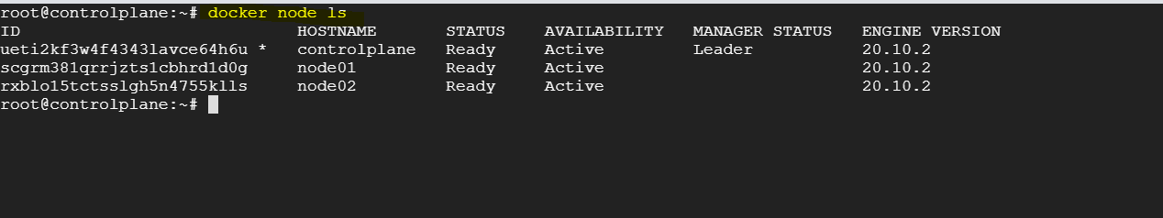
UC: how to regenerate the token?
docker swarm join-token worker
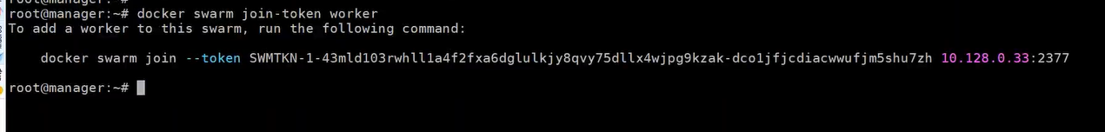
single vm (container), cluster (service- group of containers)
docker service create --name myapp --replicas 7 -p 9000:3000 lerndevops/samplepyapp:v2 # group of containers called service

docker swarm service provides horizontal scaling, self-healing and load balancing.

How to create your custom overlay network?
docker network create myoverlay --driver overlay
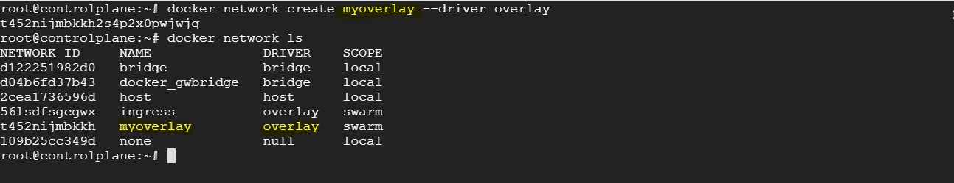

How to create a service on custom overlay network?
docker service create --name mysvc --network myoverlay --replicas=5 lerndevops/alpine:sleep
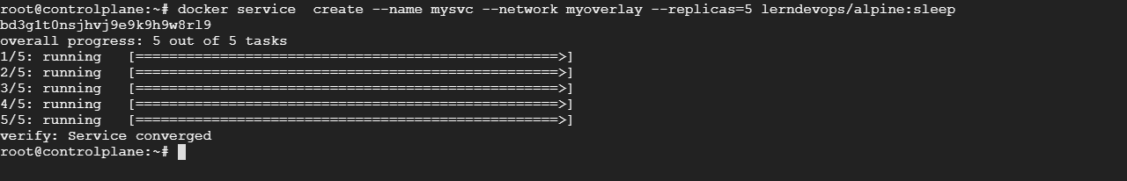
docker service ls
docker service ps <name of the svc> # detailed info of service
In master node

In worker node1
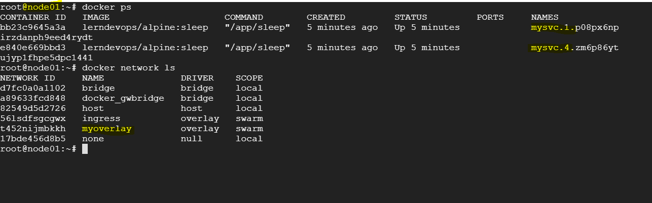
In worker node2
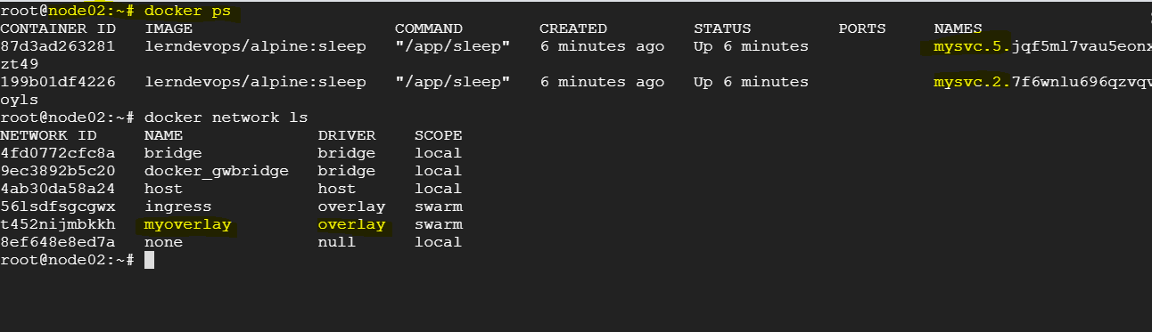
UC: Container Communication across the cluster?
In Master
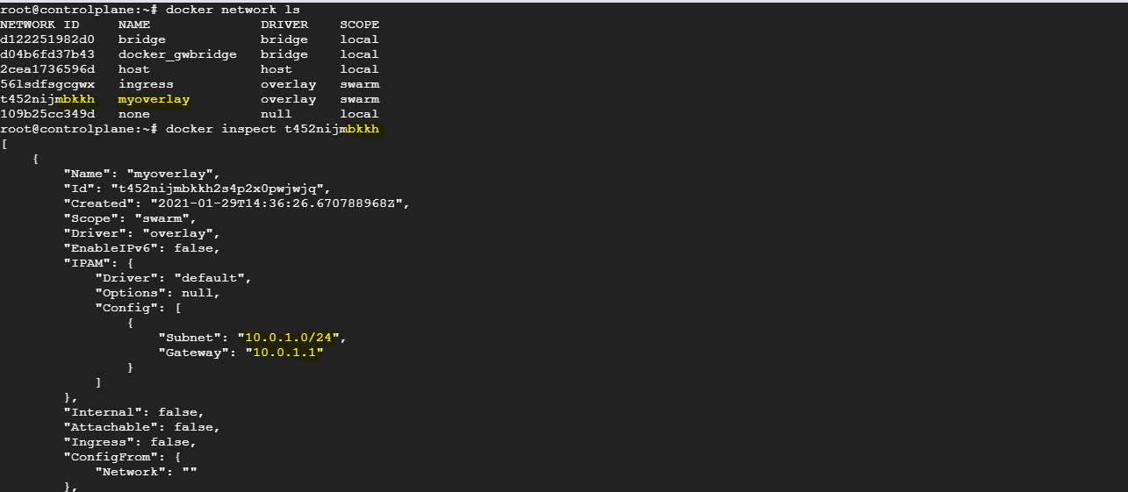
docker exec <container id> hostname –i
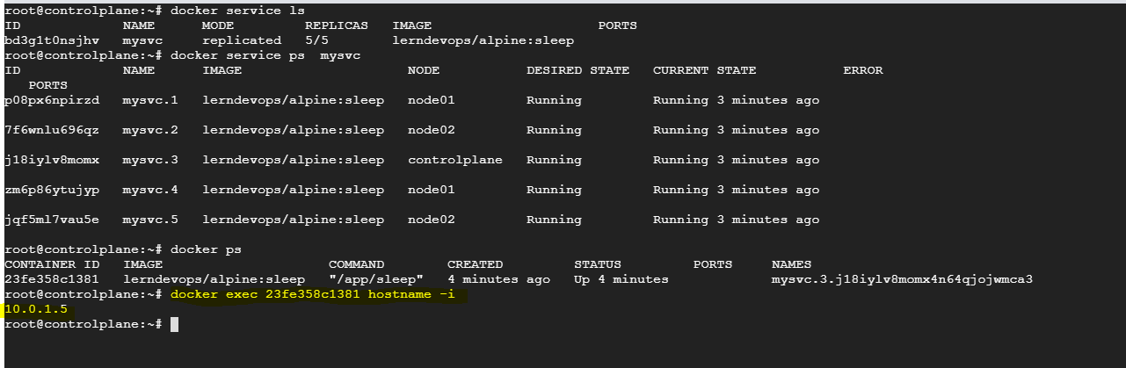
In Node01
docker exec <container id> hostname –i
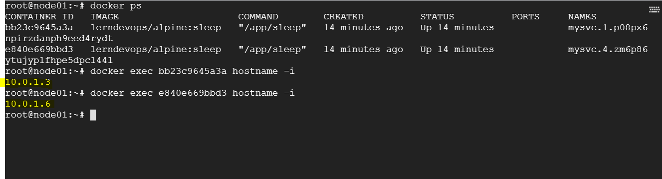
In Node02
docker exec <container id> hostname –i
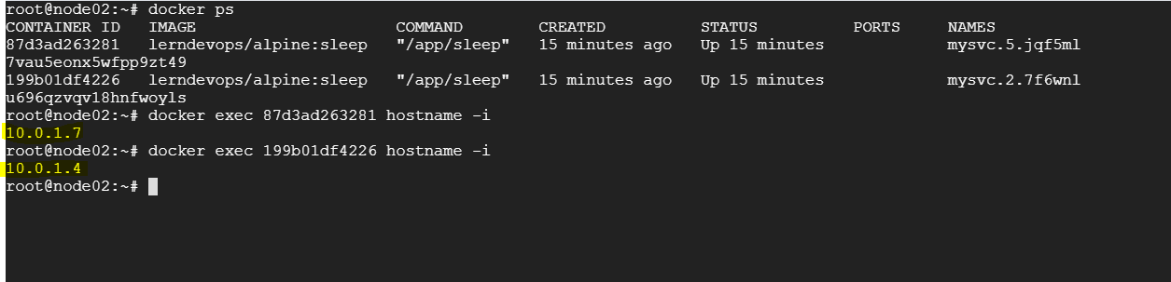
All containers are created under the same subenet, so they can ping to each other by default.
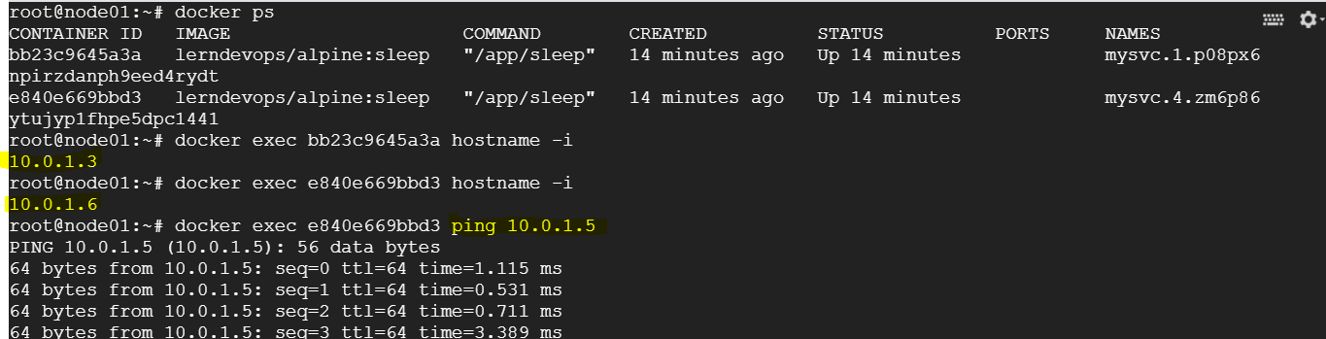
UC: we have docker is installed on master as well as on the worker nodes, communication happens between docker engine and docker engine.
How to containers in different overlay network communicates to each-other?
docker network create –help
